Blog Planning  - Time Management for Teachers |  | 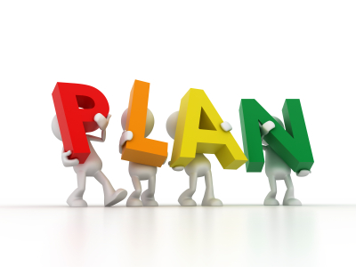

Overview  In this course you’ll learn to use a website and blog pages to organize your teaching materials. Blog Planning allows you to adapt your plans on a day-to-day basis, creating a digital resource as you go. You’ll learn to link to videos, articles, documents and more so students and parents can refer back to your lessons.  Goals  Teachers will be able to create blog post on their website to spell out the days lesson plans for students.  Requirements  A web site creator (Weebly will be demonstrated and is recommended for this course). Please contact the Help-desk (395-help) if you have any trouble accessing Weebly at school.  - Internet Connection  - Ability to access videos and images (instruction will be provided)  Evaluation  This is a product-based mini course. To successfully complete the course just meet the milestones outlined on the right-hand side and complete the course post-assessment. |  | Milestones  Create and publish a class website that includes a standard and blog page for each course taught  Creation of a post that demonstrates the ability to upload a photo, video, and insert a link

Credits

- Photo CC-Shana Montesol Johnson
- Photo CC- Photo CC-Ava Diamond
- Photo CC- Jim Simons
- Photo CC-Meredith Atwater for opensource.com
- Photo CC-S.B Maverick
- 1. Photo CC-Chandra Maharzan

