Cloud  Collaboration  - Time Management for Teachers |  | 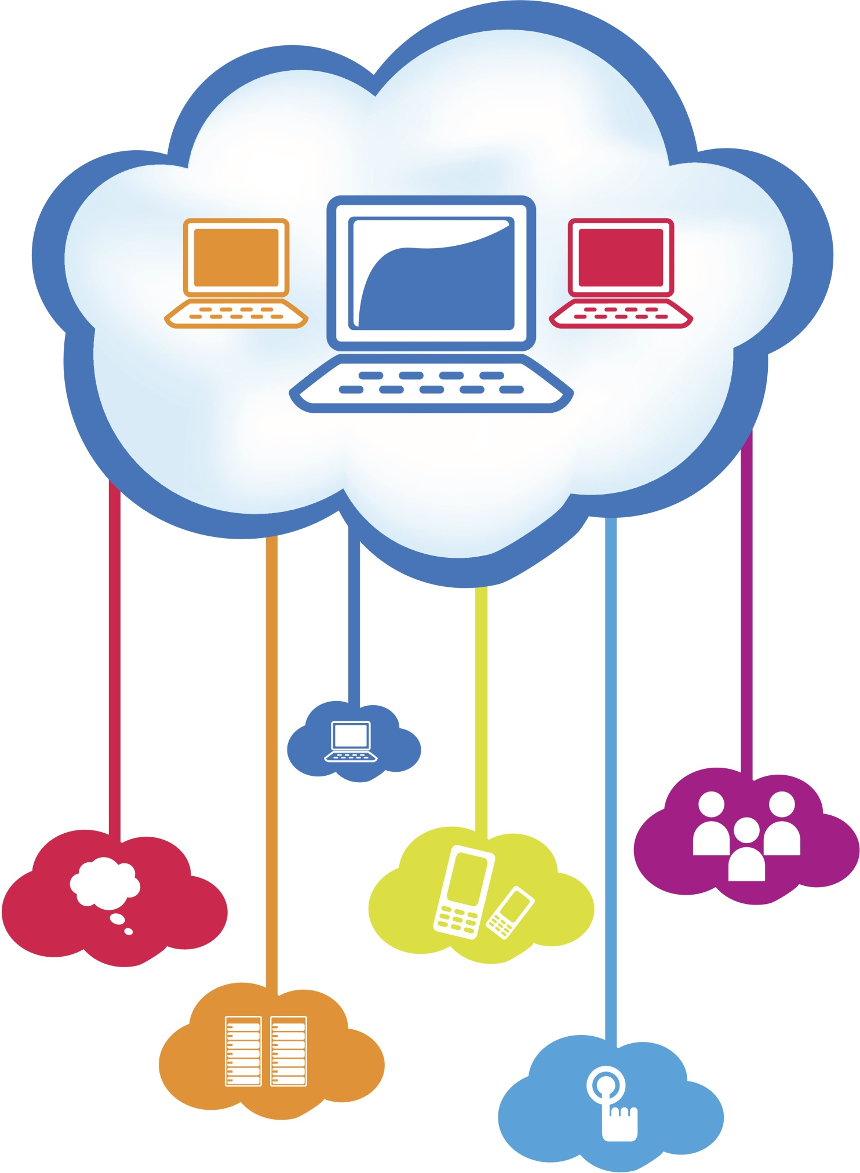

Overview  In this course, you’ll use Google Drive to set up a collaborative, cloud-based work environment. This space will help you share, edit, and collaborate on documents with students and colleagues more efficiently and effectively.  Goals  Teachers will use Google Drive to share, edit, and collaborate on documents and folders.  Requirements  A SCCPSS Google Account has been provided for all teachers and students. If you don’t know how to access or have forgotten the password to your SCCPSS Google Account, please contact your Instructional Technology Coach or the Help-desk (395-help).  - Google Account (Login with your computer login and password)  - Chrome or Firefox browser  - Internet Connection  Evaluation  This is a product-based mini course. To successfully complete the course, just meet the milestones outlined on the right-hand side and complete the course post-assessment. |  | Milestones  Create and share folders and documents using Google Drive  Add comments or edit a document in Google Forms  Evaluate how sharing folders and documents can lead to better time management & instructional practices

Copy Write Credits

- Photo CC-Cloud Computing, Stevens Heaven
- Photo CC-On Target, Sonia Tracy
- Google Docs in Plain English, By Google (2007)
- Photo CC-Start Here, DeAndre Johnson
- Teachers and Principals Talk about Google Docs, By Google (2008)
- Google Drive & Docs: Sharing & Collaboration, gcflearnfree (2012)
- Photo CC-Chandra Maharzan

