Digital  Learning Logs  - Time Management for Teachers |  | 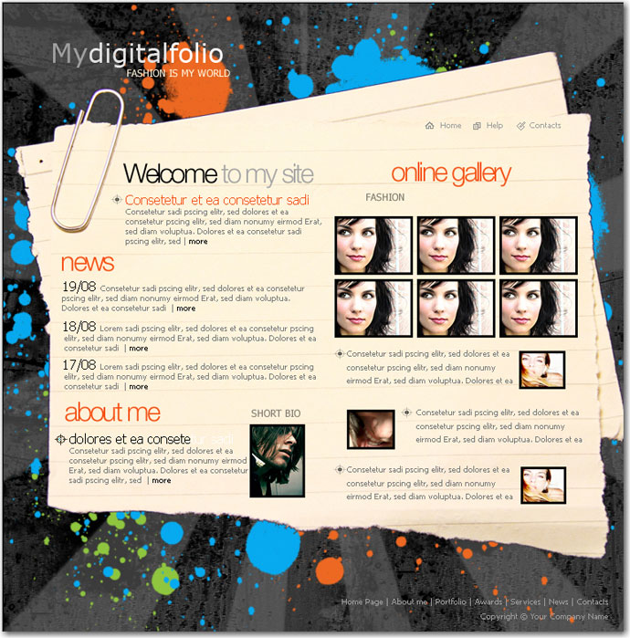

Overview  In this course you’ll learn how to set up digital learning logs for students. Learning logs offer students the opportunity to build and reflect on their learning. It’s a scrapbook of learning.  Goals  Students will use a web builder to build framework for a digital learning log.  Requirements  - An internet connection & web browser  - Student email address  - Demonstration of solid digital citizenship skills*  *Before students start to publish online, they must have a firm understanding of what it means to be a digital citizen. If your students have not had strong instruction in this topic please review the resources below before continuing.  Evaluation  This is a product-based mini course. To successfully complete the course just meet the milestones outlined on the right-hand side and complete the course post-assessment. |  | Milestones  Assess the role of digital learning logs to support authentic student engagement  Build a framework for a personal digital learning log  Publish site with a minimum of one post that includes one photo, video, and one link

Credits
- Photo CC-Ester Wright
- Photo CC-Thomas Reeves
- Photo CC-Julian Kane
- Photo CC-Chandra Maharzan

