Gather Data with Google Forms  - Time Management for Teachers |  | 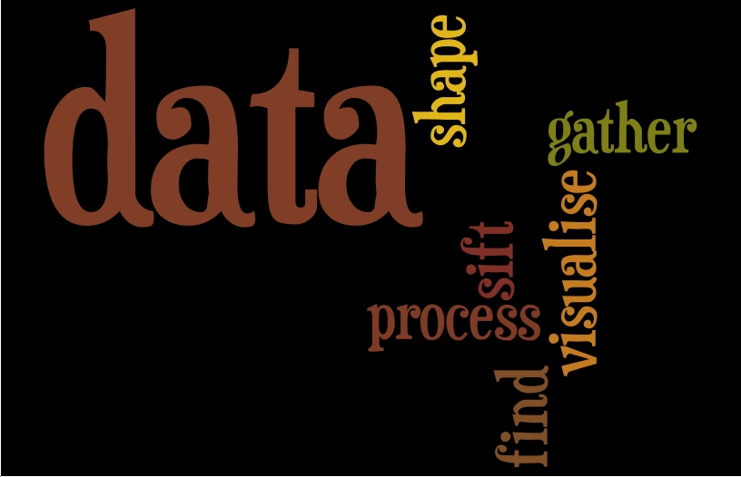

Overview  In this course, you’ll learn to use Google Forms to gather data to better inform your instruction. By using forms, you can create exit tickets, questionnaires, interest surveys, and other formative or summative assessments. The best part is results are instantly graphed so you don’t need to do any extra calculations.  Goals  Teachers will create Google Forms to gather data that can inform their instructional practices.  Requirements  A SCCPSS Google Account has been provided for all teachers and students. If you don’t know how to access it or have forgotten the password to your SCCPSS Google Account, please contact your Instructional Technology Coach or the Help-desk (395-help).  - Google Account (active directory user name and password)  - Chrome or Firefox browser  - Internet Connection  Evaluation  This is a product-based mini-course. To successfully complete the course, simply meet the milestones outlined on the right-hand side and complete the course post-assessment. |  | Milestones  Create and edit two formative assessments and one student questionnaire using Google Form  Publish the link to your Google Form  Evaluate how instant student data can lead to more informed instructional practices

Credits

- Photo CC-J.C. Westerburg
- Photo CC-ASCD
- 1. Photo CC-Chandra Maharz

